

* What is the Product/Service?

Name of Our Project is Searchable Inventory. In This project we are putting the updated inventory of your Store on maps so the user (Internet Consumer) can easily find their desire product in nearest shops and get directions to the store.

* Who is the Customer?

Customers are the Internet Consumers i.e. smart phones user’s and consumers of your store.

* How will we earn Money?

We will add subscription charges after three months on web and mobile application and 1 month free trail for stores and marts. We will get some amount of profit on sold product from your store’s revenue. We will provide you the list of traffic came through our website.

# Principal Of Effectuation Related to Our Project…

**Bird in Hand**

On very first step we only have Smartphone’s in our hands with an idea, so we just put together and make things possible try to shape up things.

**Affordable Loss**

We already know that in the beginning we have to invest our time, money and resources, we already calculated some loss for incoming situation.

**Lemonade**

Our job is to upload only exists inventories on our websites but if our customer don't have computerized inventory we will entertain them to have one.

**Patchwork Quilt**

We can also use help from off shelf product in our product, i.e. designing of our product from third party.

**Facebook response**

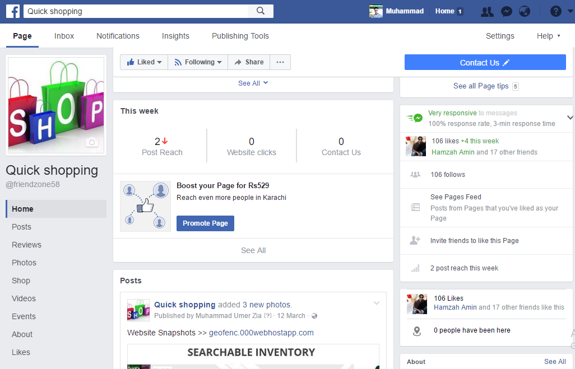

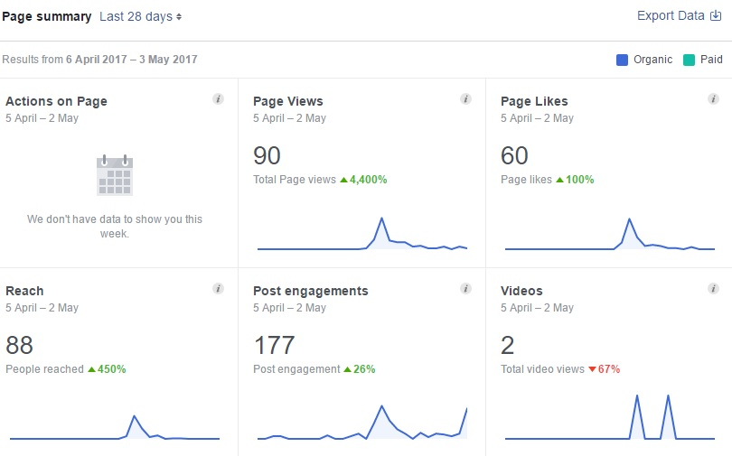

**Some Snap Shots of our Project**

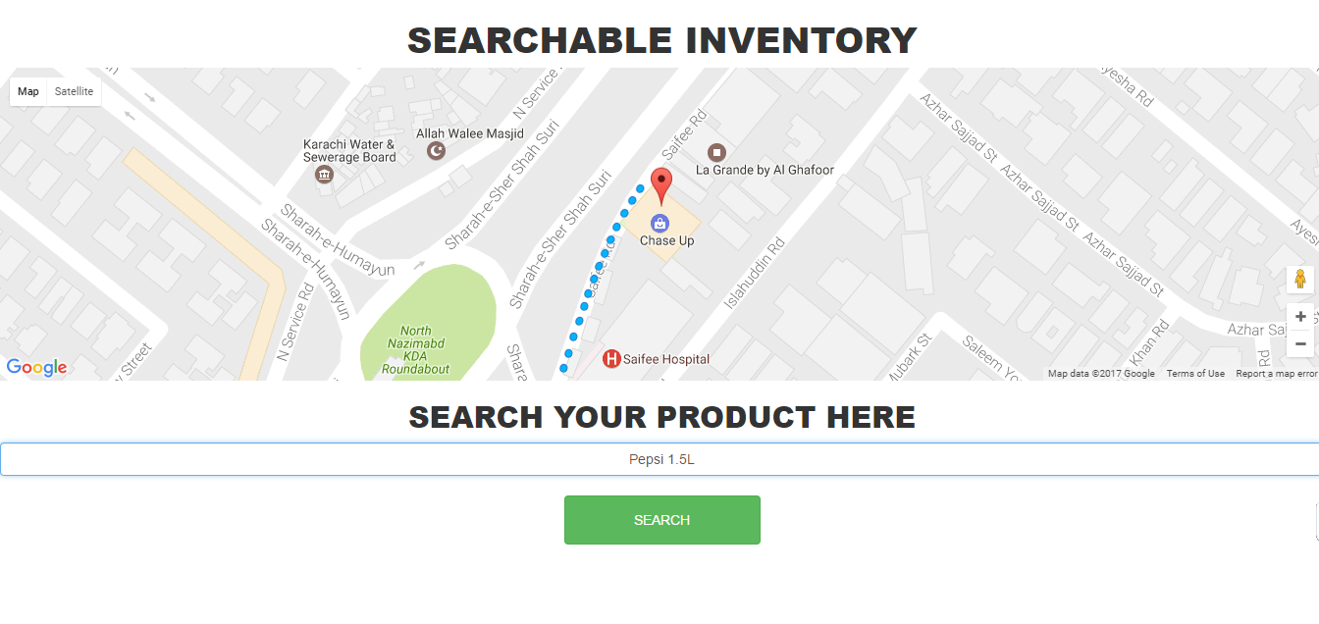

**ADVANTAGES OF SEARCHABLE INVENTORY**

* Customers search for the required product and get the path of nearest Chase Up branch where the product is available.
* Your store will get more customers through this web app within a short span.

**4**

**Future plan and procedings…..**

As we know that technology is increasing day by day so there is no way that technology involved apps or service will fail the best example is Uber and Careem we are working on the site to make it better and after that we have plans for IOS and ANDROID app for that project.